**Question 1*.**

For the following CPN system, give all enabled binding elements and all possible final markings.



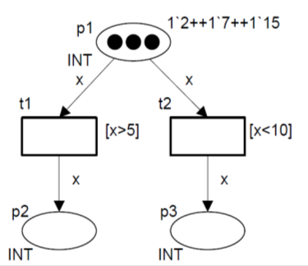

**1`6++1`10++1`20**

**Question 2.**

Consider the Place-Transition net shown in Figure 2 modeling the dining 2-philosophers system (the tokens are shown as black dots in some places.)

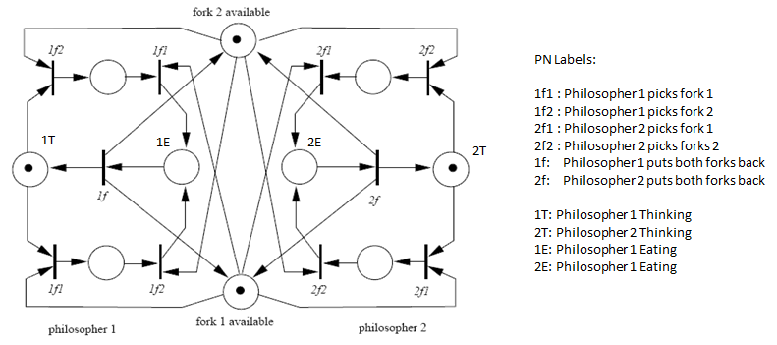

**Figure 1**

1. Model the behavior of the philosophers as a folded Colored Petri net. Describe the folding of places and transitions.
2. Specify the properties of the [C]PN Systems (in Fig. 1 and Part a, above) in terms of
3. **deadlock**
4. **liveness**
5. **reversibility**
6. **concurrency** and **conflict**
7. **boundedness**
8. Describe any difference(s) in the properties you observed between the systems in Fig. 1 and Part (a).

**Question 3*.**

The following CPN model allows more money to be withdrawn from an account than the balance. Change the model such that the balance cannot become negative, i.e., do not accept transactions which lead to overdrafts. Place appropriate tokens in places and execute to show that the model is fixed with your modifications to the model.

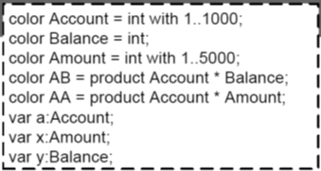

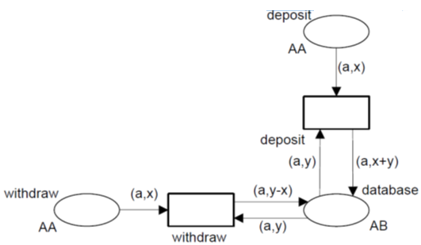

*From lecture notes of 

**Question 4.**

In this problem, you are asked to develop a Colored Petri net model for a fictitious railroad loop that has ***six sectors*** (i.e., Sector 1 to 6) in it and ***two trains*** are running in the loop (clockwise). The following are the constraints that the trains must satisfy at all times.

1. All sectors have a capacity of one train occupying them except for Sector 1 which has a capacity of two trains, i.e., maximum of two trains may be present at the same time in Sector 1.
2. Train 1 requires an empty sector ahead of it at all times (except when entering Sector 1).
3. Train 2 is an experimental train and requires two empty sector ahead of it at all times (except when entering Sector 1).
4. Initially, all trains are in Sector 1.

*Note: Use of CPN Tools is not required. You may draw it paper-pencil or use the software. You are, however, required to be syntactically accurate.* ***It will be easier for me to grade if you use the following base CPN for your model.*** *You may submit your .cpn file with your solutions on BB.*

colset Train = with Train1 | Train2;

var t : Train;

FinalQ3.eps